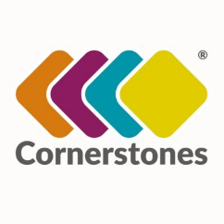
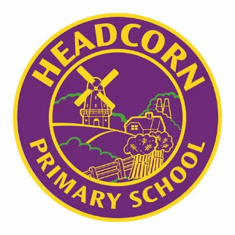
Headcorn Primary School History Overview
Aspiration. Inclusion. Resilience.

EYFS

Term 1 and 2 | Term 3 and 4 | Term 5 and 6
Cornerstones | Cornerstones  Signs of Spring: people, culture and communities  Starry Night: past and present  Winter Wonderland: people, culture and communities | Cornerstones  Sunshine and Sunflowers: people, culture and communities  Big Wide World: past and present; people, culture and communities
EYFS Curriculum | EYFS Curriculum  Past and Present:  Talk about the lives of the people around them.  People, Culture and Communities:  Describe their environment; compare life in this country and life in other countries, making links with a range of texts. | EYFS Curriculum  Past and Present:  Talk about the lives of the people around them.  People, Culture and Communities:  Describe their environment; make comparisons between different communities, making links with knowledge from their lives and texts shared; share stories and talk about people who lived in the past- explain why they are significant.

