
Key Question
1.2 Who is a Muslim and what do they believe?

Key Vocabulary

Prior Knowledge
1.7 What does it mean to belong to a faith community?
1.6 How and why do we celebrate special and sacred times?

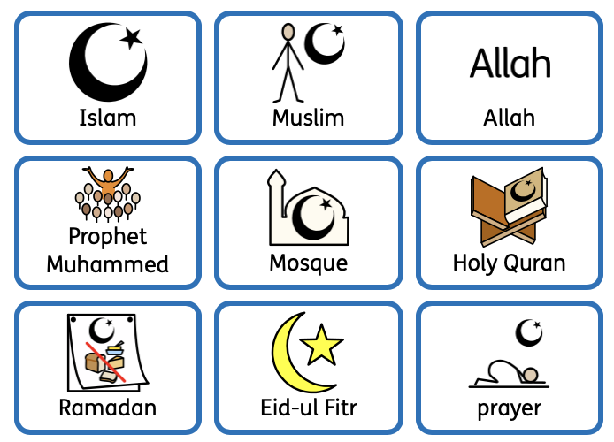

Key Knowledge
The Muslim word for God in the Arabic language is Allah.
Muslims believe that the world would not function without Allah.
The prophet Muhammed is a special leader for Muslims who taught all Muslim people how to follow Allah.
Muslims make no pictures of the prophet Muhammed.
Muslims believe that the prophet Muhammed:
- Cared for all Allah’s creation.
- Forbade cruelty to any animal and cared for animals himself.
- Believes in fairness and justice for all.
Muslim’s place of worship is called a Mosque.
The Holy Qur’an is the sacred text for Muslims.
Muslims celebrate Eid-ul Fitr to celebrate the successful completion of Ramadan. Ramadan is a time when Muslims fast during daylight hours.



