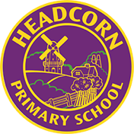
Key Question
1.3 Who is Jewish and what do they believe?

Key Vocabulary

Prior Knowledge
1.7 What does it mean to belong to a faith community?
1.6 How and why do we celebrate special and sacred times?

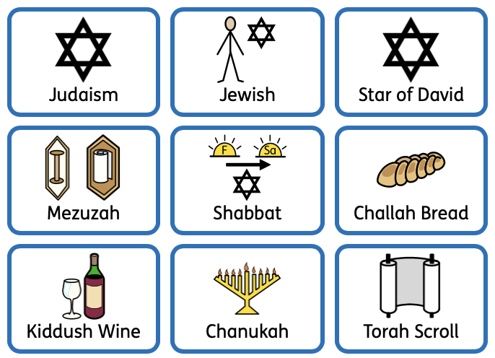

Key Knowledge
The Star of David is the Jewish symbol.
Jewish people believe in one God.
A mezuzah is a scroll with prayers from the Torah scroll written on it in Hebrew. It is kept in a case and kept on the doorpost of Jewish people’s homes.
Shabbat is a holy day each week where many Jewish people rest and really think about God.
Shabbat is welcomed with a special meal on a Friday night of Challah bread, Kiddush wine, prayer, and songs.
Chanukah is a Jewish celebration that lasts for 8 days in December. Jewish people remember the story of Chanukah and the miracles in it, where the small Jewish army of Maccabees beat a much larger army.
They light a hanukkiah, a multibranched candle lit for 8 days, as a reminder of oil lasting for 8 days in the story.



