
Key Question
1.6 How and why do we celebrate special and sacred times?

Key Vocabulary
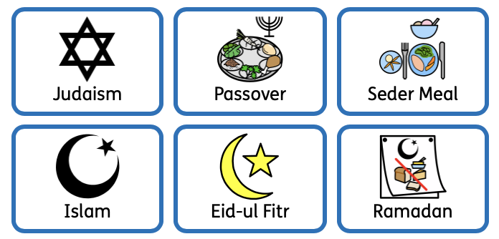

Prior Knowledge
1.6 How and why do we celebrate special and sacred times (Easter)

Key Knowledge
Jewish people retell the story of Passover, or Pesach, every year.
Jewish people believe that God told Moses that the Israelites should mark their doorposts with lamb’s blood so that the angel of death could ‘pass over’ their houses and spare them from the plague.
Jewish people celebrate Pesach with a traditional Seder meal.
On the Seder plate are foods without yeast so they can remember the haste in which their ancestors left Egypt having no time to let their bread rise.
Muslims celebrate Eid-ul Fitr to celebrate the successful completion of Ramadan. Ramandan is a time when Muslims fast during daylight hours. When they feel hungry it helps them to think about people who don’t have enough food.
During Ramadan it is a time to study the Qur’an, think about Allah and give to charity. Eid-ul Fitr is a time to celebrate and give thanks to Allah.
We will think about the similarities and differences between Pesach and Eid-ul Fitr.



