
Key Question
1.8 How should we care for others and the world and why does it matter?

Key Vocabulary
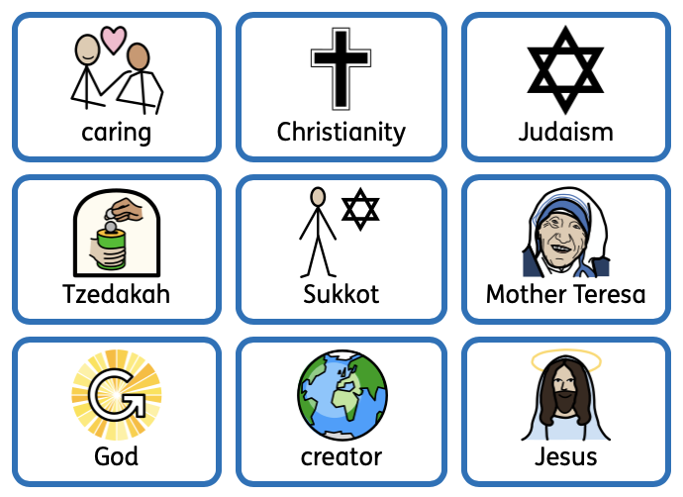

Prior Knowledge
1.1 Who is a Christian and what do they believe?

Key Knowledge
Each person is unique, valuable and important. This means we should care for each other and treat each other with kindness.
Christians learn about caring for each other through stories in the bible. We will learn the story of the Good Samaritan and four friends take the paralysed man to Jesus.
Tzedakah is the Jewish idea of charitable giving to those who need help, making the world a better place, fairer and more just.
Jewish people help those less fortunate than them during the Jewish festival of Sukkot.
We will learn about important, inspiring people who put their beliefs into action and cared for others such as Mother Teresa.
Christians believe God is a wise, caring creator who is interested in people and all life.








