

Key Question
1.1 Who is a Christian and what do they believe?

Prior Knowledge
We are all different and we all have different beliefs and faiths.
Christianity is a religion.
Christians believe in Christianity.

Key Vocabulary

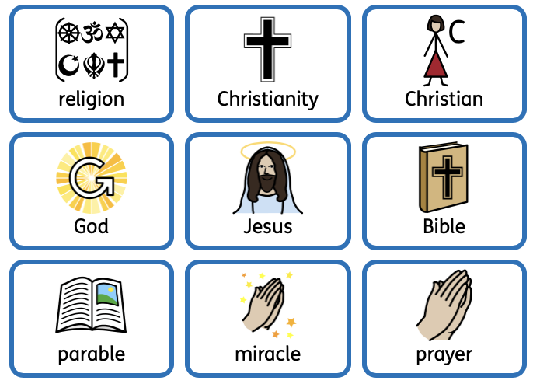

Key Knowledge
Christians believe in God.
Christians follow the examples of Jesus.
Christians communicate with God through prayer.
Parables in the bible teach Christians about God. We will learn the stories of Jonah, The Lost Sheep and the Good Samaritan.
Christians believe Jesus performed miracles. We will learn the stories of Jesus and the Ten Lepers and the Feeding of the Five Thousand.
We will make links between what Jesus taught and what Christians believe and do.



