
Key Question
1.6 How and why do we celebrate special and sacred times? (Easter)

Key Vocabulary

Prior Knowledge
1.1 Who is a Christian and what do they believe?
Our own personal celebrations of Easter.

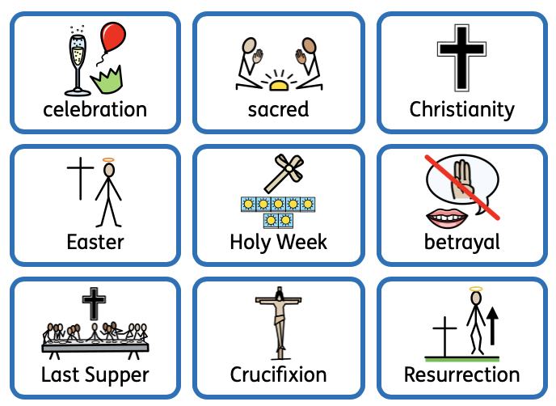

Key Knowledge
Celebrations are important to us and each celebration is held for a reason.
Easter is a Christian celebration.
We will learn the key events of Holy Week:
- Procession into Jerusalem - Palm Sunday
- The Last Supper
- Being betrayed by Judas
- Crucifixion
- Resurrection
We will learn how Christians celebrate Easter.



