
Key Question
1.7 What does it mean to belong to a faith community?

Key Vocabulary

Prior Knowledge
We are all different and we all have different beliefs and faiths.
1.1 Who is a Christian and what do they believe?

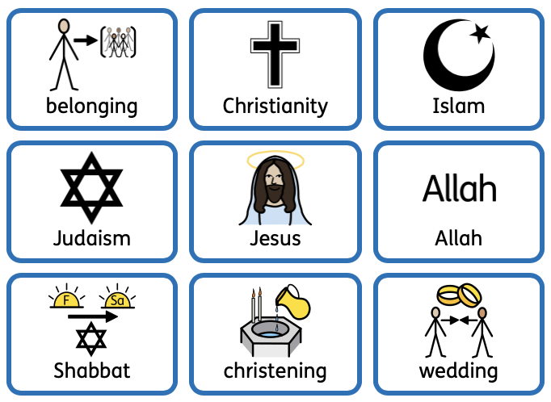

Key Knowledge
We all belong to something and belonging is an important part of our lives.
Christians all belong to a group. They believe they belong to Jesus and Jesus belongs to them.
Christian symbols of belonging include the cross, the bible and Jesus.
Muslims all belong to a group. The most important thing that Muslims belong to is Allah, which is the Muslim word for ‘God’.
Symbols of belonging in Islam include Allah, the prophet Muhammed, and the Ka’aba in Mecca.
Jewish people all belong to a group. Jewish symbols of belonging include challah bread, Kiddush wine and candles.
Shabbat is a special meal for Jewish people.
We will learn how a new baby is welcomed into different religions and how weddings are celebrated in different religions.



