

Key Question
1.5 What makes some places sacred?

Prior Knowledge
1.1 Who is a Christian and what do they believe?
1.7 What does it mean to belong to a faith community?

Key Vocabulary

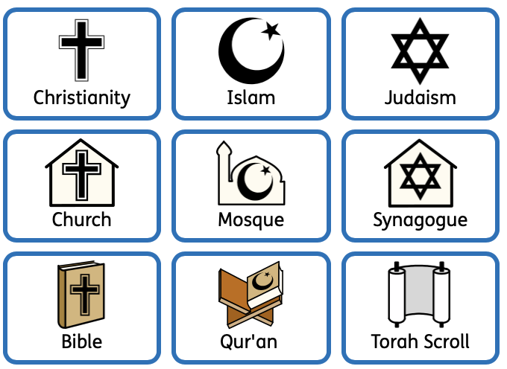

Key Knowledge
Some things and places can be described as ‘sacred’ and ‘holy’. This means that it has a special connection with God.
A church is a sacred place for Christians where they might worship.
Special objects or symbols you might find in a church include the altar, cross, font, lectern, Bible and candles.
A synagogue is a sacred place for Jewish people where they might worship.
Special objects or symbols you might find in a synagogue include the Ner tamid, ark, Torah scroll, tallit and tefillin.
A mosque is a sacred place for Muslims where they might worship.
Special objects or symbols you might find in a mosque include wuzu area, calligraphy, prayer mat, prayer beads and mihrab.
We will look for similarities and differences between places of worship.
We will learn why places of worship are important to our community.

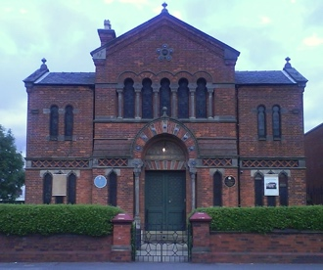
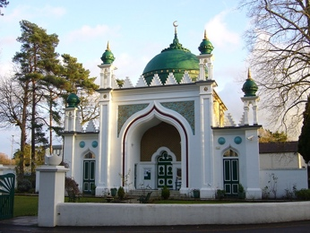
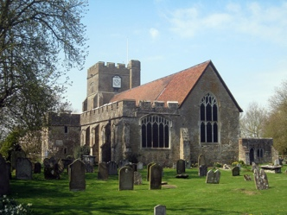

Synagogue
Mosque
Church

